India Meteorological Department
National Weather Forecasting Centre
Mausam Bhawan, Lodi Road
NewDelhi-110003
NOWCAST GUIDANCE & IOP ADVISORY FOR 24Hrs

Date: 06 October, 2018 Time of issue: 1300 IST

Chief Synoptic Features:
♦ Southwest monsoon has further withdrawn from remaining parts of North Bay of Bengal, Chhattisgarh and Maharashtra, entire Telangana, most parts of central Bay of Bengal, Coastal Andhra Pradesh and Central Arabian Sea and some parts of Rayalaseema and Karnataka.
♦ The withdrawal line of southwest monsoon passes through Lat 16°N/Long 94°E, Lat 15°N/long 90°E, Machilipatnam, Kurnool, Gadag, Vengurla and Lat. 16°N/ Long 60°E. Southwest monsoon is very likely to withdraw from remaining parts of the country and simultaneously northeast monsoon rains are very likely to commence over Tamilnadu & Puducherry, Kerala and adjoining parts of Andhra Pradesh and Karnataka around 8th October.
♦ The Well-Marked Low Pressure Area over Southeast Arabian Sea and neighbourhood now lies over Southeast and adjoining East-Central Arabian Sea. Associated cyclonic circulation extends upto 7.6 Km above mean sea level. It is very likely to concentrate into a Depression and move northwestwards during next 24 hours. It is very likely to intensify into a Cyclonic Storm and move towards Oman Coast thereafter.
♦ The cyclonic circulation over south Andaman Sea & neighbourhood persists and now extends upto 5.8 km above mean sea level.
♦ Another low pressure area is likely to form over central and adjoining south Bay of Bengal around 8th October. It is likely to become more marked and move to towards Odisha and adjoining north Andhra Pradesh Coasts during the subsequent 72 hours.
♦ The cyclonic circulation over Bangladesh and adjoining areas of Assam & Meghalaya persists and now extends upto 1.5 km above mean sea level.
♦ The Western Disturbance as an upper air cyclonic circulation over north Pakistan & adjoining Jammu & Kashmir now lies over northern parts of Jammu & Kashmir and neighbourhood at 5.8 km above mean sea level.
♦ The induced cyclonic circulation extending upto 0.9 km above mean sea level over northwest Rajasthan & neighbourhood now lies over North Rajasthan and neighbourhood.
♦ A fresh Western Disturbance is likely to affect western Himalayan region and adjoining plains of northwest India from 08th October

IOP Area for Day-1:

Significant Rainfall:
Tamilnadu & Puducherry, Kerala, Lakshadweep Islands, Coastal & South Interior Karnataka
Andaman & Nicobar Islands

Thunderstorm with Lightning:
Tamilnadu & Puducherry, Kerala, South Interior Karnataka

Thunderstorm with Gusty winds: Nil

Thunderstorm with Hail: Nil

Graphical Presentation of Potential Areas for Severe Weather (IOPs):

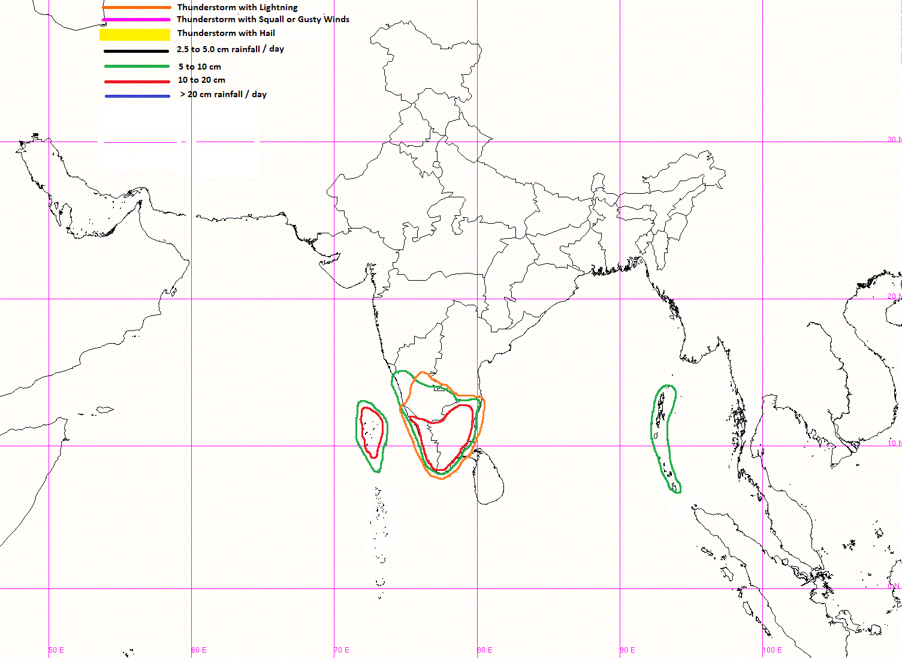
IOP Advisory for 24 hours

